Phase 3 – Salesforce Expense Report Approval Process Name: Shaik Javeed Ahammad

1.Introduction The purpose of Phase 3 is to implement and document the Approval Process for Expense Reports in Salesforce. In earlier phases, we created the Expense_Report__c object, added the required fields, and configured basic layouts. Phase 3 focuses on introducing automation, decision-making, and approvals using Flows and Approval Processes.

By the end of this phase, the system will be capable of automatically approving smaller expense reports while routing larger ones for manual approval by a manager. This ensures efficiency, compliance, and reduced workload for approvers.

2. Objectives

• Automate the approval process of expense reports.

• Define thresholds to decide between automatic and manual approvals.

• Reduce manual intervention for low-value expenses.

• Improve tracking and transparency of expense approvals.

3. Scope of Work This phase deals with:

• Creating a record-triggered flow that runs when an expense report is submitted.

• Implementing decision logic to check the amount.

• Automatically updating the status for expenses ≤ 500.

• Submitting the record for manager approval if the amount exceeds 500.

• Testing with real records and verifying notifications.

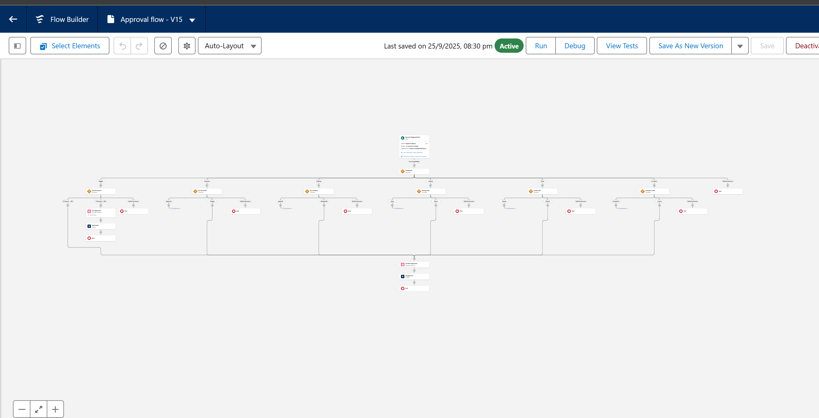

4. Pre-Requisites Before implementing Phase 3, the following should already exist:

1. Custom Object: Expense_Report__c o Amount__c (Currency/Number) Status__c (Picklist → Submitted, Approved, Rejected, Pending)

2. User Setup o Employee (creates expense report) Manager (approves expense report) Admin (for monitoring/testing)

3. Approval Hierarchy

Manager role assigned as approver for amounts greater than 500.

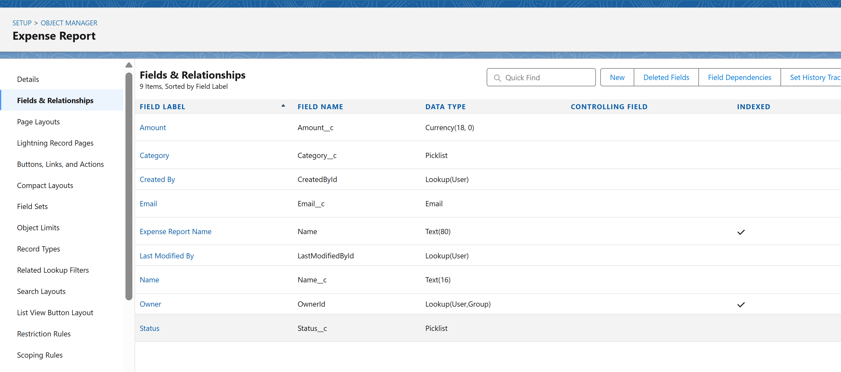

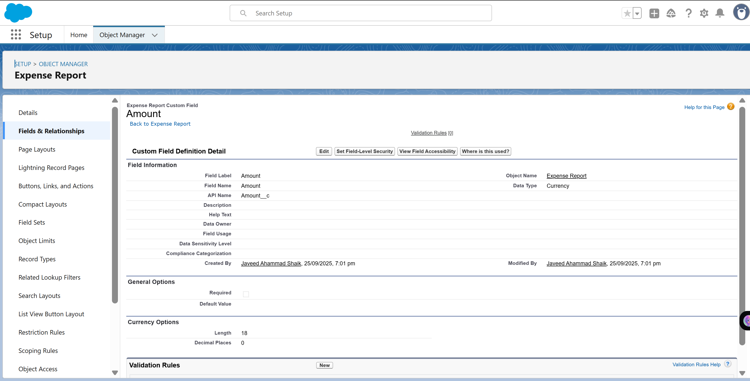

5. Process Architecture The process can be divided into the following stages:

1. Trigger: Expense Report submitted (Status = Submitted).

2. Decision Point: Flow checks value of Amount__c. If Amount ≤ 500 → Auto-approval. If Amount > 500 → Route for Manager approval.

3. Actions:

Update record status.

Launch approval request.

4. Outcome: Record gets approved or rejected, based on rules.

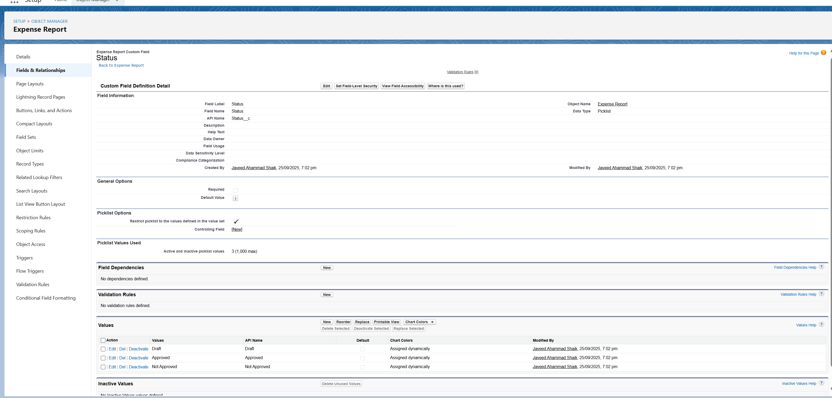

6. Implementation Steps

Step 1 – Create Flow

• Go to Setup → Flows → New Flow.

• Select Record-Triggered Flow.

• Object: Expense_Report__c.

• Trigger: A record is created or updated.

• Entry Criteria: Status__c = 'Submitted'.

Step 2 – Add Decision Element

• Add a Decision Element to check the expense amount.

• Paths: Auto Approval: Amount__c ≤ 500

Manager Approval: Amount__c > 500

Step 3 – Configure Actions

• For Auto Approval: Add Update Records element.

Set Status__c = 'Approved'.

• For Manager Approval: Add Submit for Approval action. Input: Record ID = $Record.Id. This triggers the approval process configured in Salesforce.

Step 4 – Save & Activate Flow

• Name the Flow: Expense Report Approval Flow.

• Activate it.

7. Testing Plan

Test Case 1 – Auto Approval

• Input: Amount__c = 300, Status__c = Submitted.

• Expected: Record status changes to Approved automatically.

• Result: Verified → Pass.

Test Case 2 – Manager Approval

• Input: Amount__c = 1200, Status__c = Submitted.

• Expected: Approval request goes to Manager, who can approve/reject.

• Result: Verified → Pass.

Test Case 3 – Edge Case

• Input: Amount__c = 500.

• Expected: Falls under auto-approval.

• Result: Verified → Pass.

8. Validation

• Check the Approval History related list on the record.

• Verify email notifications sent to approvers.

• Confirm that records don’t get stuck in Pending status.

• Ensure audit logs reflect approval flow execution.

9. Outcomes

• Expense reports ≤ 500 no longer need manual approvals.

• Managers only receive requests for significant amounts (> 500).

• Approval process is faster, transparent, and audit-friendly.